

|  |  |  |  |  |  |  |  |  |
| --- | --- | --- | --- | --- | --- | --- | --- | --- |
|  | | | | | | | | |
|  | | Self-Learning Project | | | | |  | |
|  |  | | | | | | |  |
|  | | | |  |  | | | |
|  | | | | Group B **Waleed Farhan Alanazi**  **444100378** |  | | | |
|  | | | | 1/18/2023—CS101—Alhaf Malik Mohaideen |  | | | |
|  | | |  | | |  | | |



|  |  |  |  |  |  |  |  |  |
| --- | --- | --- | --- | --- | --- | --- | --- | --- |
|  |  | | |  |  | | |  |
|  | ACKNOWLEDGEMENT | | | | | | |  |
|  |  | | |  |  | | |  |
|  |  | |  | | |  | |  |
|  |  |  | With my group, we had achieved something none of us could achieve alone. By combining our efforts, we were able to make a website consisting of 5 Pages and many elements contributing to the website design. I would like to thank our Instructor, Alhaf, for giving us this amazing opportunity to work together and hope that we could make more amazing projects down the line. | | |  |  |  |
|  | | | | |
|  |  |  |  |
|  |  |

Table of contents

ACKNOWLEDGEMENT 2

THE PROCESS 4

The Process 5

Why did we select HTML? 5

Who are the members of our group? 5

Step 1: creating the folders and necessary files. 7

Step 2: Opening the folder in Visual studio code. 8

Step 3: creating the HTML and CSS files 9

Step 4: Inserting the page text and content 10

Step 5: Creating an image gallery 11

Step 6: Adding videos 12

Step 7: Adding the navigation functionality 12

Step 8: Beautifying our website 13

Step 9(Last step): hosting our website 15

References and Sources 18

Information 18

Pictures 18

Videos 18



|  |  |  |  |  |  |  |  |  |
| --- | --- | --- | --- | --- | --- | --- | --- | --- |
|  | |  |  | | |  |  | |
|  | | THE PROCESS | | | | |  | |
|  | |  |  | | |  |  | |
|  | Introduction Me and my team kicked things off by deciding on the website Layout then started to gather information, pictures, and videos about the 2030 Vision to use on our website. Then we started to make our site from scratch using various applications which we will discuss later in the report. | | | | | | |  |
|  | Website Layout The Layout is one of the most important aspects of a website especially the type of the website we wanted to make. We settled on a common Layout used by many modern websites; it consists of a permanent header and a launch page from which you can access all pages from anywhere on the website which can be beneficial for anyone who is interested in a specific project but has no interest in other projects. | | |  | As well as being easy and efficient to use, the layout we chose offers much needed simplicity while on the negative side not being too expandable, we settled on five pages only because more than that seemed extensive to use. | | |  |



# The Process

#### Why did we select HTML?

HTML is a platform independent used to create your own website. HTML describes the structure of a Web page.HTML consists of a series of elements. HTML elements tell the browser how to display the content. HTML elements are represented by tags. These tags mostly come in pairs like <h1> and </h1>. HTML tags label pieces of content such as "heading", "paragraph", "table",” image”, and so on. Browsers do not display the HTML tags but use them to render the content of the page. Using HTML, we can create hyperlinks to navigate to different documents present on the web.

#### Who are the members of our group?

|  |  |  |  |
| --- | --- | --- | --- |
| No. | Name | ID | Role |
| 1 | Waleed Farhan Alanazi | 444100378 | Leader and programmer |
| 2 | Mazen Fahad Alamry | 444100224 | Information gathering and report writing |
| 3 | Fahad Majed Alhethail | 444100327 | Report analyzing and team management |
| 4 |  |  | Layout and design |

|  |  |  |  |  |  |  |
| --- | --- | --- | --- | --- | --- | --- |
|  | The steps involved in making the website. | | | | |  |
|  | |  |  |  |  | |
|  |  | | | | |  |

### Step 1: creating the folders and necessary files.

We started this step by heading to the computer desktop then creating the folder which was named : SL Project – 2030 Vision, then we created another folder inside that folder which we named : Images, this folder will be crucial later on so we can put all of our images and use them from there (We planed on using more images but haven’t had the chance to do so).

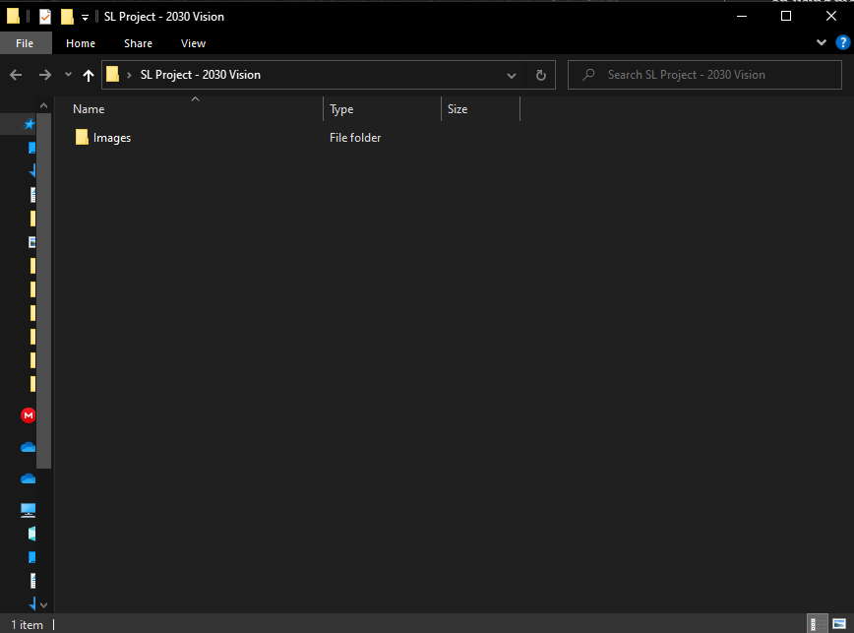

This is how our folder looked like.

### Step 2: Opening the folder in Visual studio code.

We chose to use visual studio code since it provided many useful tools that will help making the website creation process way much easier and at the same time allows us to manipulate file types which is important for creating .html files.

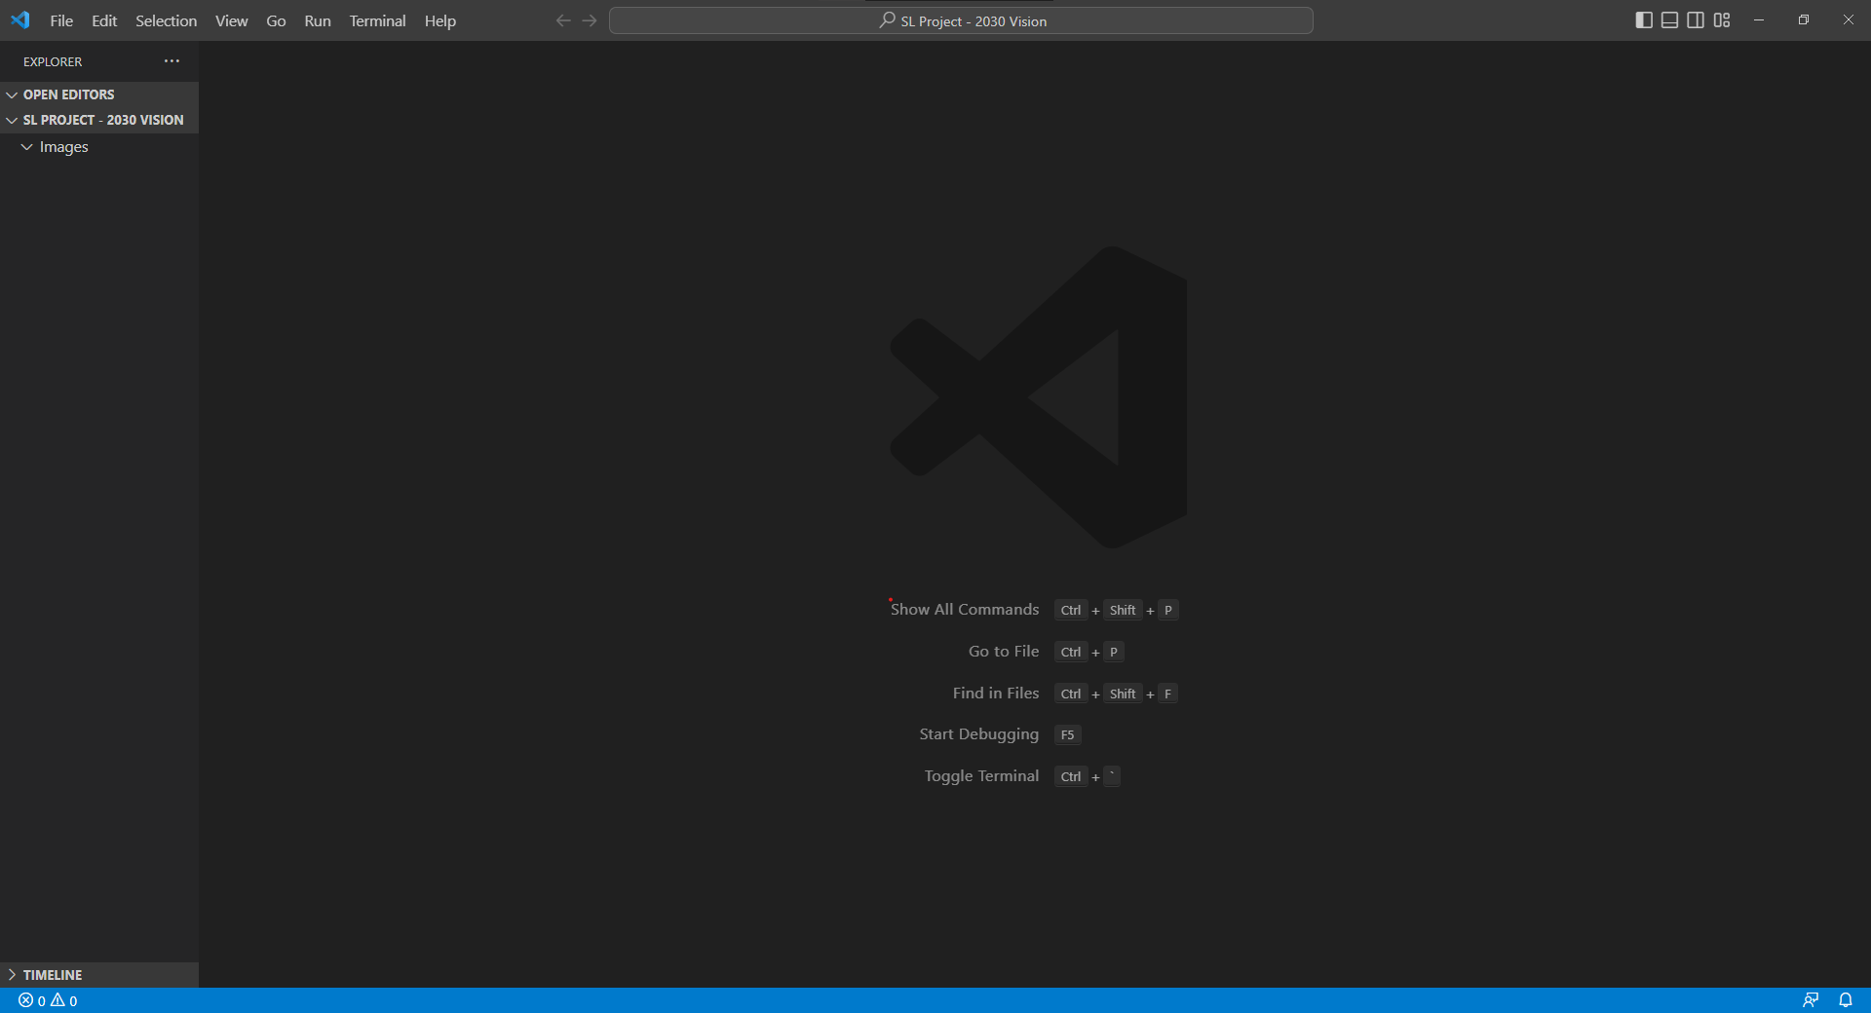

This is how VS code looked like when we first opened it.

#### Adding images

Images are crucial when making websites so we made sure to search for great sources for images since we do not want any low-quality image that could ruin the experience and the immersion for which we were heading.

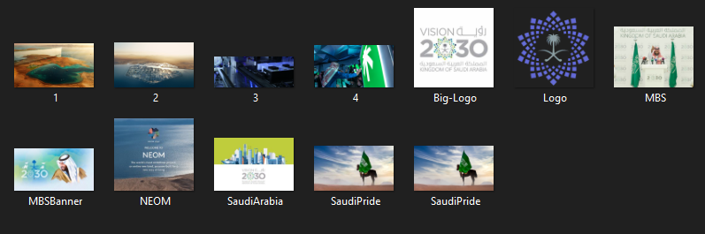

We did not choose many images because we wanted to keep the website simple and easy on the eye, we settled on a single image for each page.

### Step 3: creating the HTML and CSS files

Since we had 5 pages, we created 5 HTML files and only one CSS file and linked them all together then added the Header in each HTML file and made sure that each file has a unique representative abbreviation.

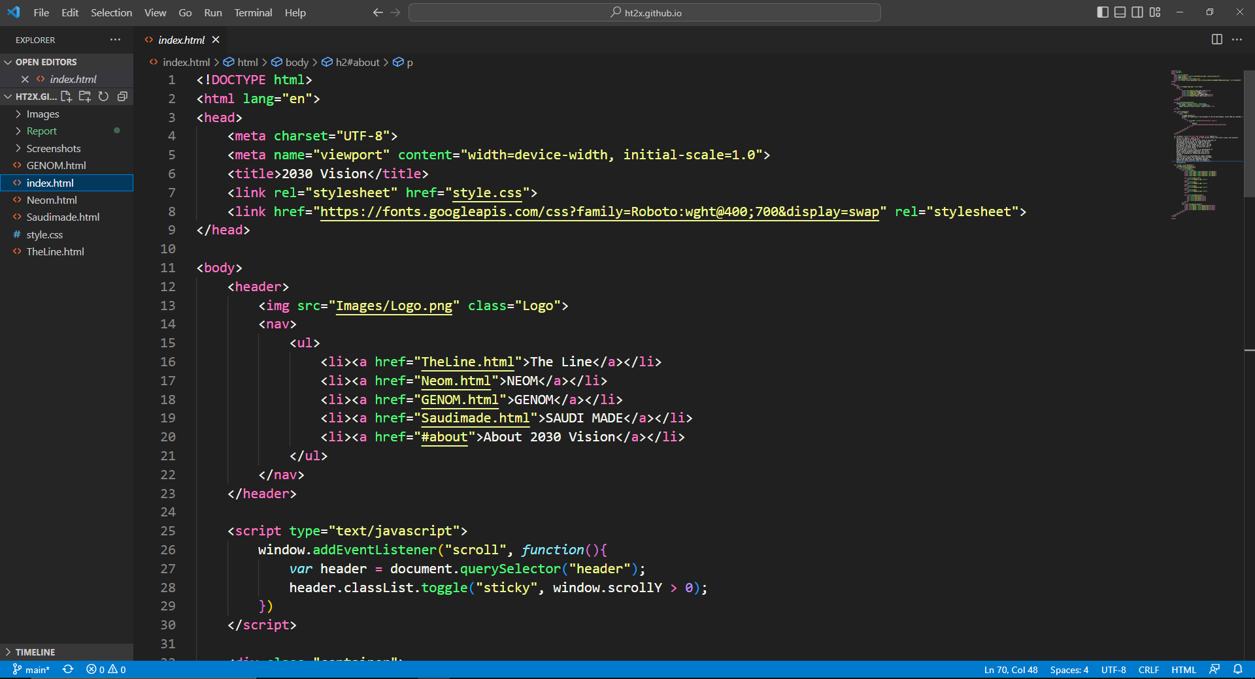

### Step 4: Inserting the page text and content

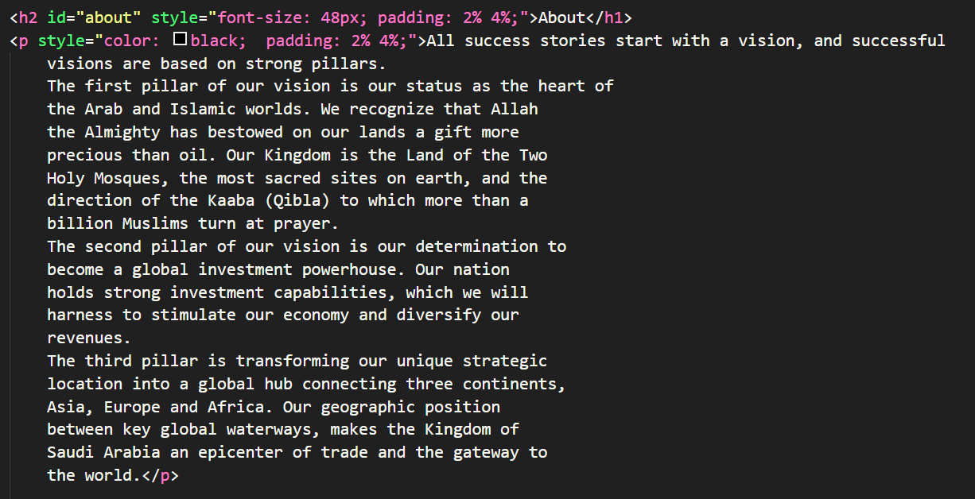

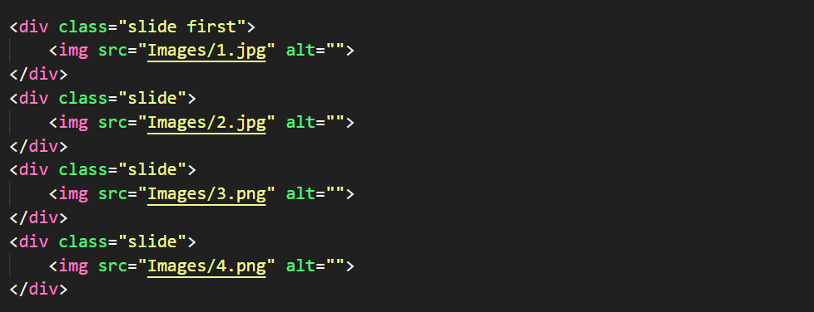

Sources for all the content will be provided at the end of the report.

We mainly used Pinterest for image gathering for its huge collection of high quality images.

### Step 5: Creating an image gallery

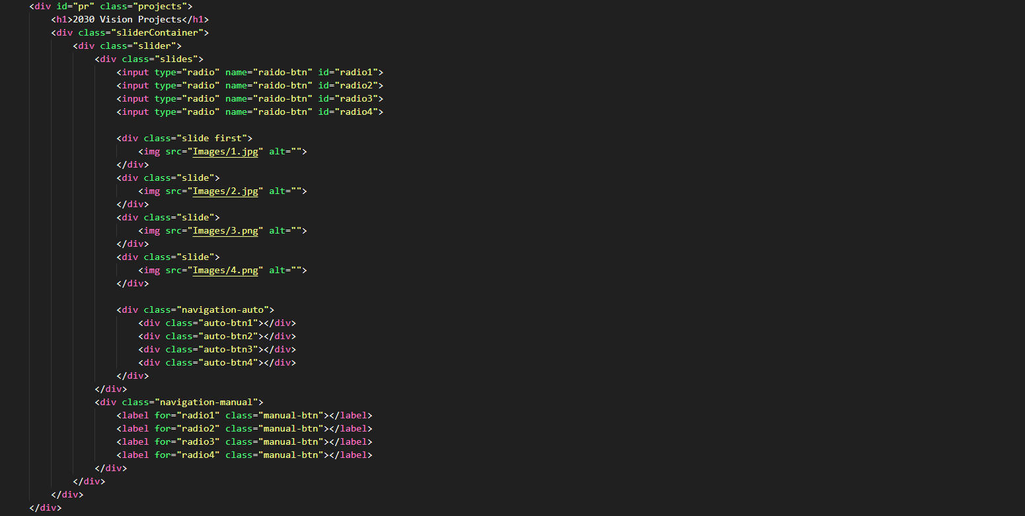

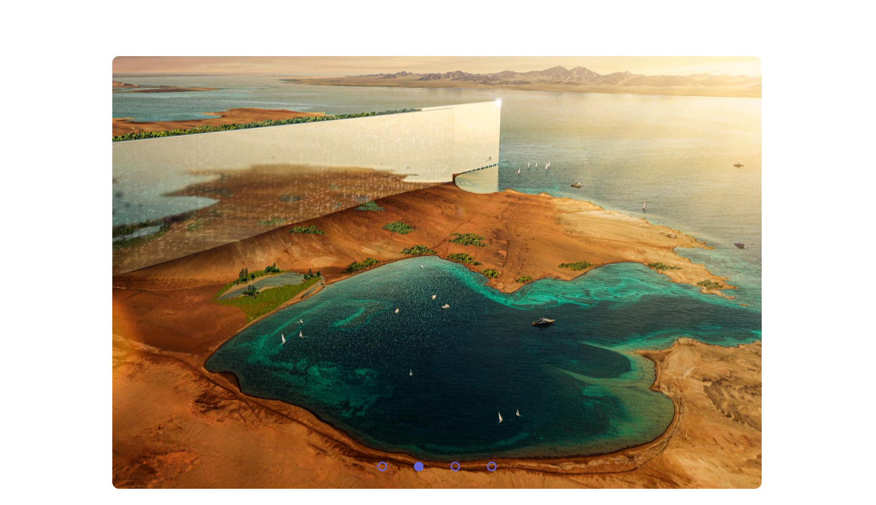

### Step 6: Adding videos

Of course no website is completed without some action!

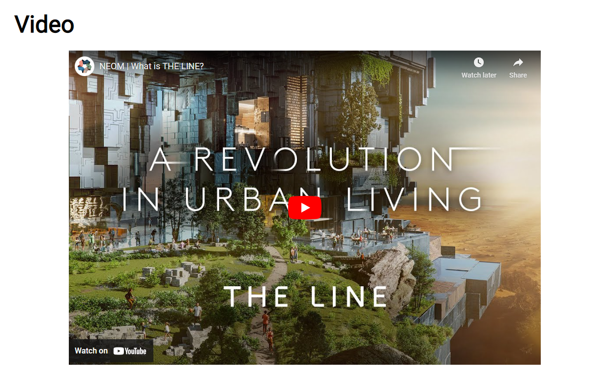

### Step 7: Adding the navigation functionality

A header is not worth anything without functionality… a wise man once said.

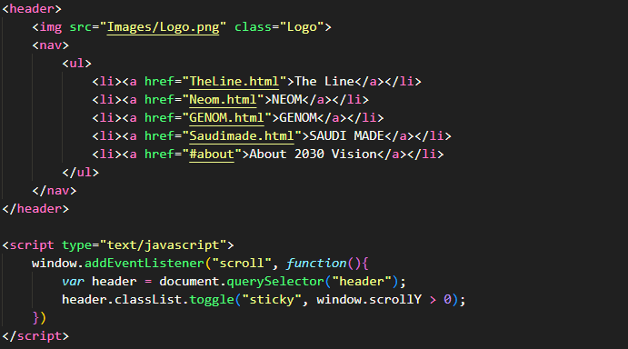

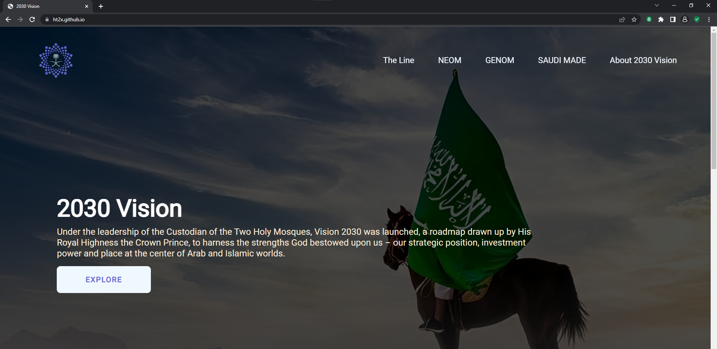

### Step 8: Beautifying our website

CSS is a powerful tool which is crucial for any website designer, it allowed us to customize our website in every single aspect. The code for the CSS is long but here are some snippets of important parts:

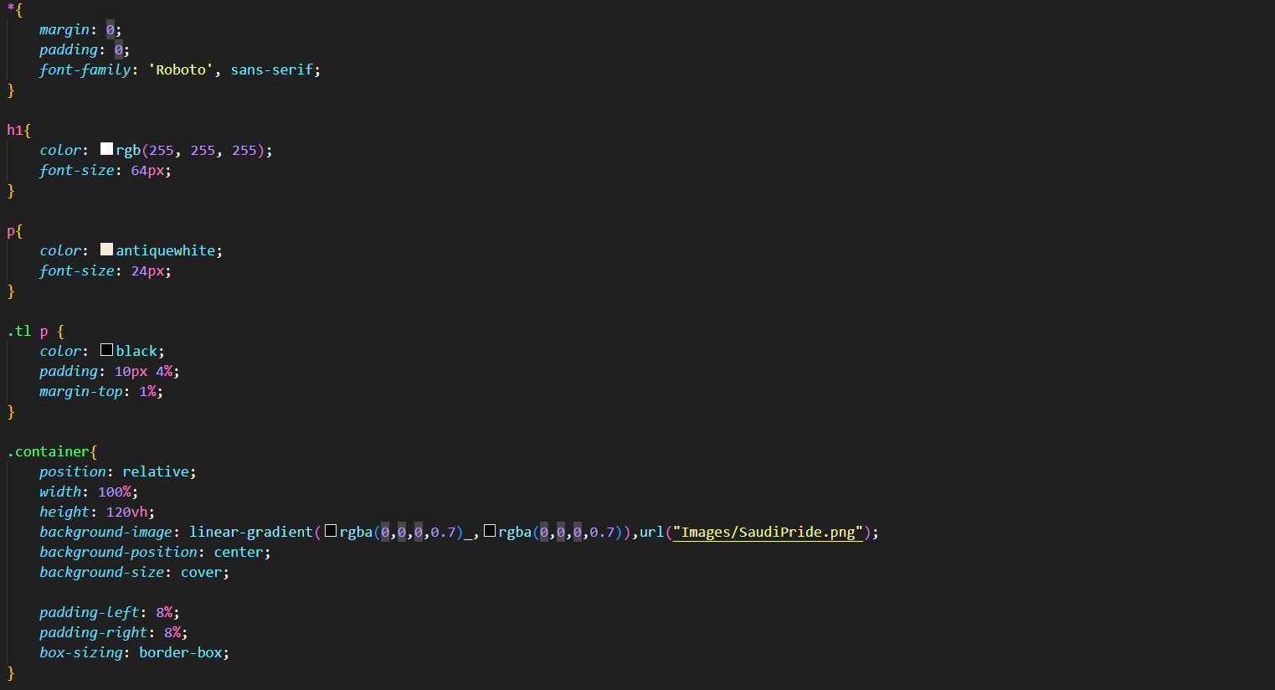

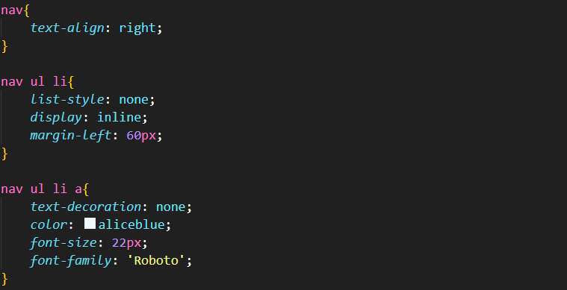

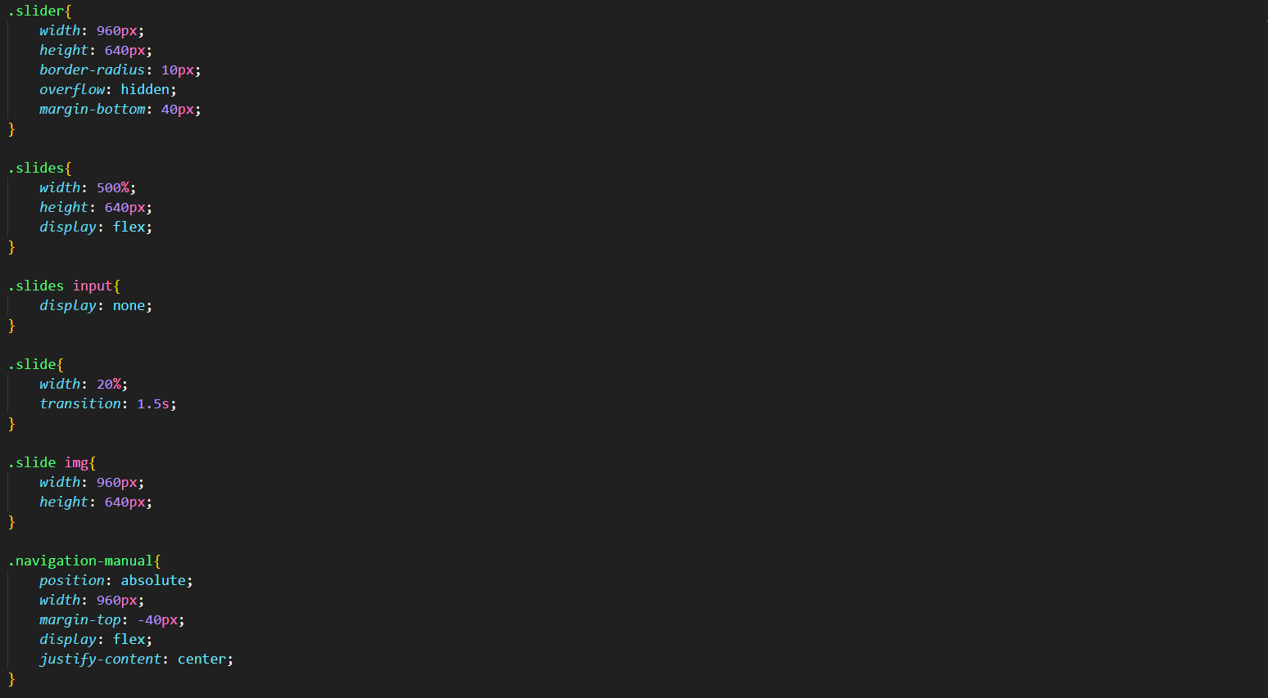

### Step 9(Last step): hosting our website

We used GitHub for hosting our website since it is free and relatively easy to use. Our website is hosted on ht2x.github.io which is a free domain provided by GitHub, they also provide hosting services for free!

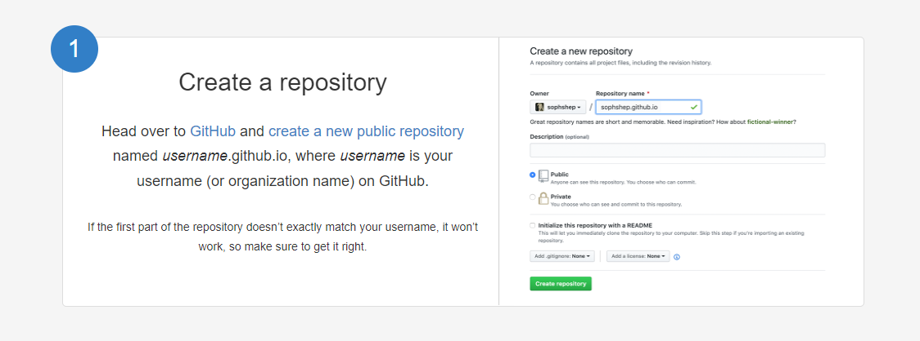

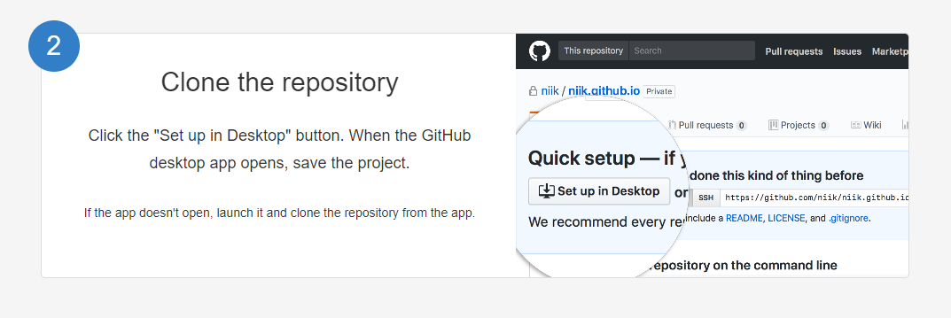

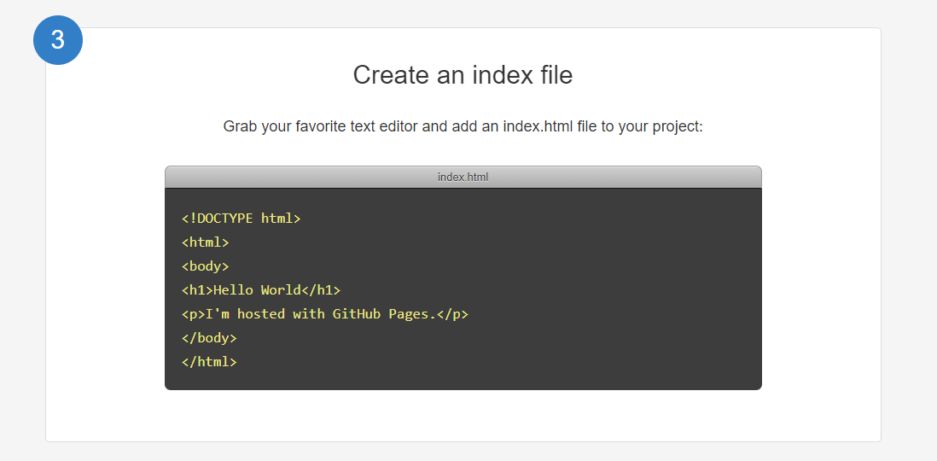

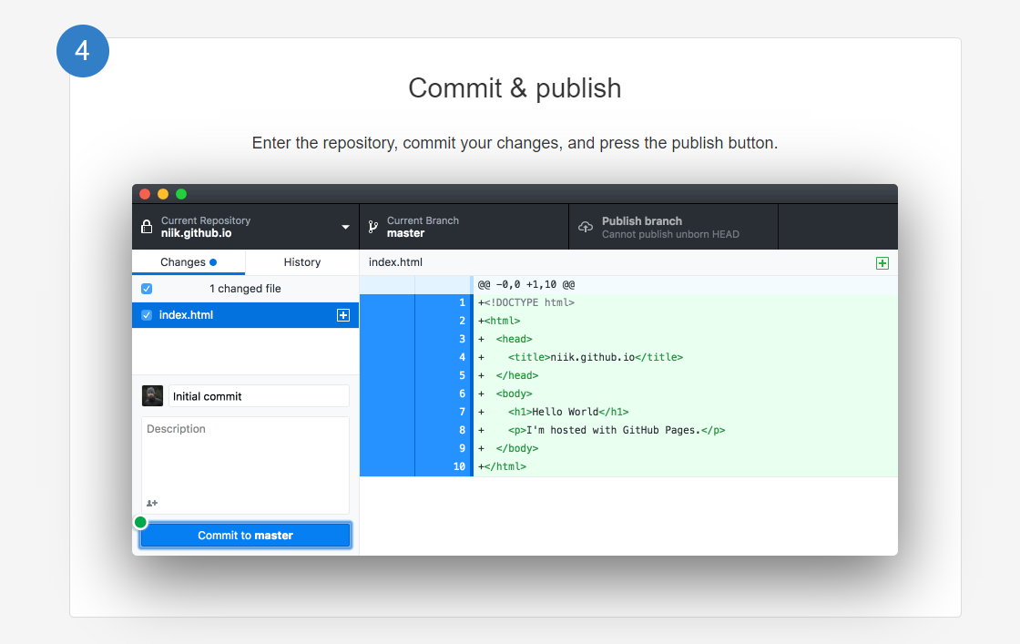

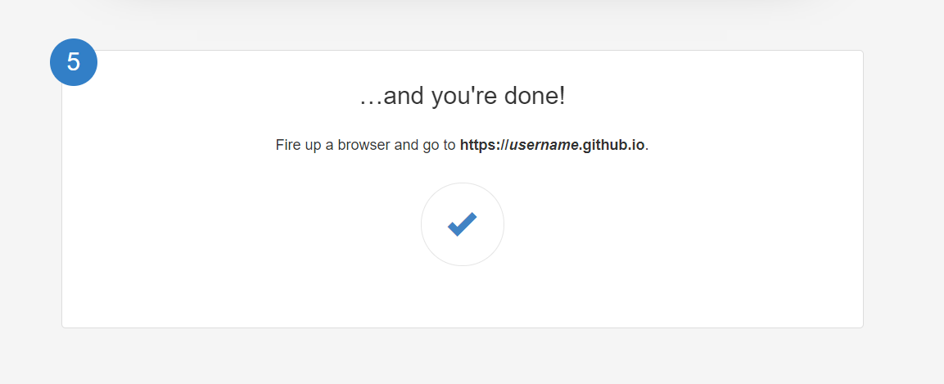

# References and Sources

### Information: the official website of the 2030 Vision.

### Pictures: Pinterest & the official website of the 2030 Vision.

### Videos: the main channel of NEOM.